Design diwali led lights

Circuit diagram

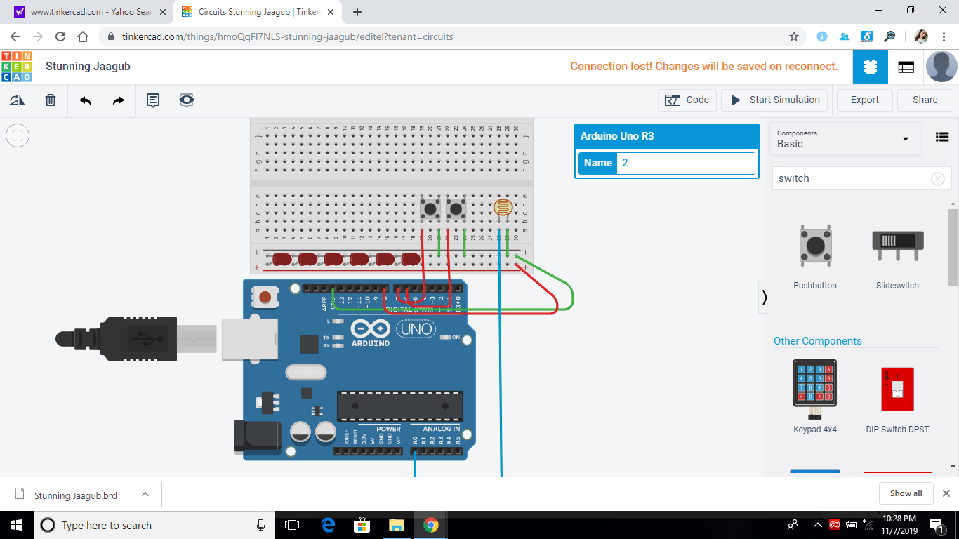

Theory

**Code:-**

void setup()

{

pinMode(8,OUTPUT);

pinMode(7,INPUT);

pinMode(6,INPUT);

Serial.begin(9600);

}

void loop()

{

Int sensorvalue=analogRead(A0);

Serial.println(sensorvalue);

Delay(100);

Int reading1=digitalRead(7);

Int reading2=digitalRead(6);

If(sensorvalue<300) {

{ if(reading1==HIGH)

digitalWrite(8,HIGH);

delay(500);

digitalWrite(8,LOW);

delay(500);

} if(reading2==HIGH)

{digitalWrite(8,HIGH);

delay(1000);

digitalWrite(8,LOW);

delay(1000);

}

else{ digitalWrite(8,LOW); }

}

**CONCEPT USED:-**

**I had** use the concept of if or else program in this for verifying the condition that photoresistor is reading dark and bright for LED’s

**LEARNING :- I have** learn about that by vering the value of lumx photoresistor we can use it in different condition .

**Problem:-** the program was not working at first but by changing in the sensorvalue condition we get our result.

**PRECAUTION:-** we have to connect each device point to point in the circuit

Apply resistor before led to avoid short circuit.

**OUTCOME:-** that we can make several more circuits related to this circuit for the benifts .

I have also learn how to make projects online .